Lesson plan
Long-term plan: The world of work |  |  |  | School: №1
Date: |  |  |  | Teacher name: Akhmetova G
Grade: 5 "В" |  |  |  | Number present: |  | absent:
Theme of the lesson: |  |  |  | Jobs
Learning objectives(s) |  |  |  | 5.L1 understand a sequence of supported classroom instructions  5.S3 give an opinion at sentence level on a limited range of general and curricular topics  5.S4 respond with limited flexibility at sentence level to unexpected comments on an increasing range of general and curricular topics  5.R6 recognise the attitude or opinion of the writer in short texts on a limited range of general and curricular topics  5.R7 recognise typical features at word, sentence and text level in a limited range of written genres  5.C2 use speaking and listening skills to provide sensitive feedback to peers  5.C8 develop intercultural awareness through reading and discussion  5.W8 spell most high-frequency words accurately for a limited range of general topics  5.W9 punctuate written work at text level on a limited range of familiar general with some accuracy  5.UE10 use present continuous forms with present and future meaning on a limited range of familiar general and curricular topics
Lesson objectives |  |  |  | All learners will be able to:  - know the different types of jobs  - describe professions  - ask and answer to the questions about jobs  Most learners will be able to:  - - predict the answers to the questions about jobs  - think critically about the different aspects of jobs by generating questions  Some learners will be able to  - understand the features of jobs that are not given the at the lesson  - ask complex questions
Success criteria |  |  |  | Leaners will practise and revise most topics from Unit 4  Learners can answer the question  Learners can use prepositions and some new words
Cross curricular links |  |  |  | Humanities
ICT skills |  |  |  | PPT, Video, Worksheets, DVD-ROM
Previous learning |  |  |  | Countrie’s value
Plan
Planned timings | Planned activities |  |  |  |  |  | Resources
Beginning  5 mins  3 mins  4 mins | Greeting students  -Good afternoon, my friends! I am glad to see you. Take your seats and get ready for the lesson. How are you?  -I am very well too. Do you know what date it is today?  - Yes, right you are. It is the 5^{h} of December.  Warm up  T: Pupils take the parts of pictures and divide into 2 groups.  1st group name is – Teachers  2nd group name is – Doctors  Previous learning.  Your home task was to learn new words by heart.  Let’s check how did you do it?  1.Who looks after sick people? Doctor  2. Who plays and poses for pictures with kids? Theme park mascot  3. who protects people? Police officer  5. Who makes bread and cakes? Baker  6. Who check financial records? Accountant  7. Who grows flowers and trees? Gardener  8. Who takes food to peoples homes? Pizza delivery boy.  Ex 4 p. 47  I give you one minute time to think whether the jobs on p. 45 are indoors or outdoors. |  |  |  |  |  | PPP
  Indoors | Outdoors
  Doctor | Police officer
  Accountant | Gardener
  Baker | Theme park mascot
  Cashier | Pizza delivery boy
Middle  3 mins  5 mins  3 mins  5 mins  7 mins | Presentation of the new lesson.  Ex 3 p.47  Now it is time to introduce job qualities.  Listen to the recorder and repeat the words all together.  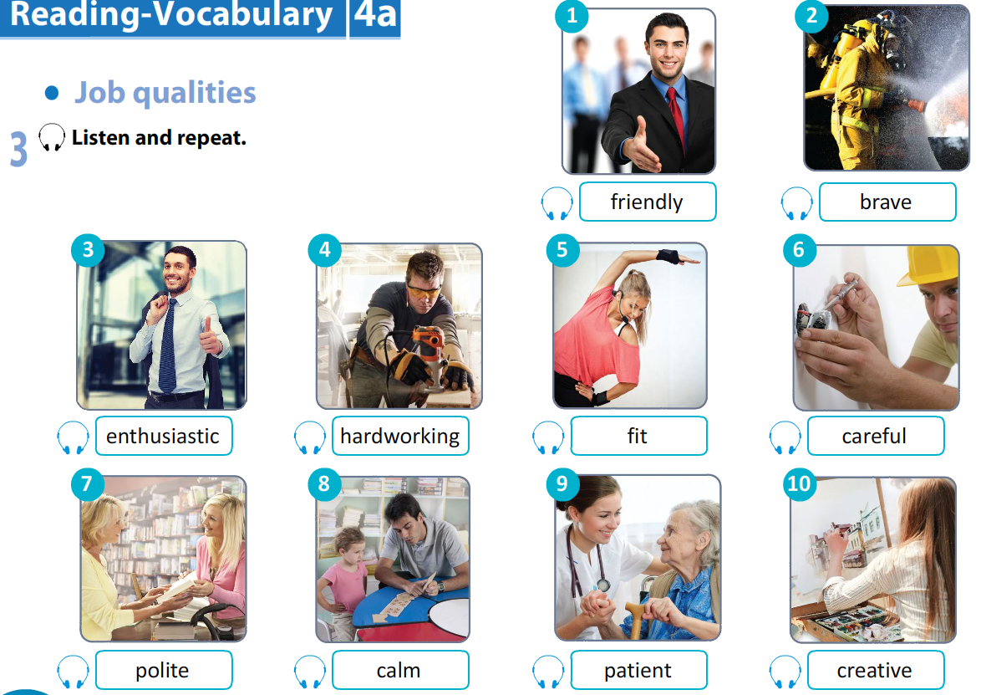  Crossword  Find and circle the names of the job qualities.  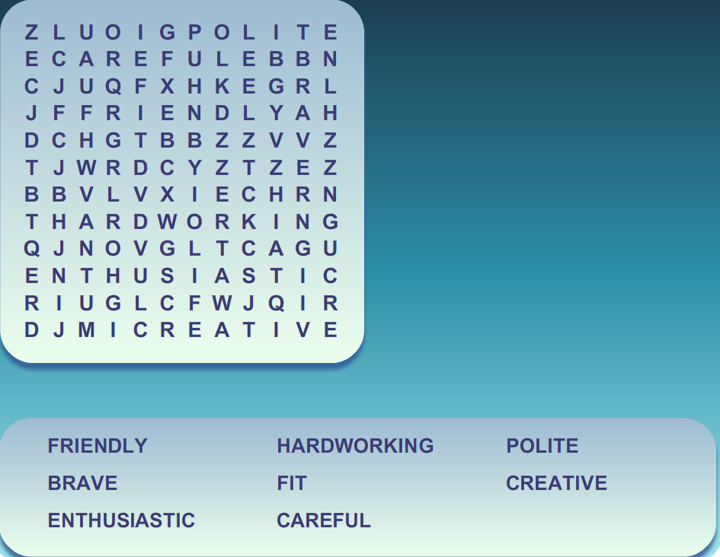  Assessment  Criteria-based assessment with teacher’s right answer  Descriptor  Learners can solve the crosswords concerning to the jobs  Learners can remember and learn the new words  Ex 4 p. 47 In writing form.  Which of the qualities in Ex 3 are necessary for each one of the jobs in Ex 1 on p. 45.  Write sentences, as in the example.  A doctor needs to be hardworking, calm and patient.  Group work: Ex. 1 p.46  a)Pre-listening task: Vocabulary related to the video.  VIDEO  b) While listening task: Learners watch the video. Pupils must answer the question  What is each person’s job. They must listen and read to find out.  What is Steven? He is a basketball mascot.  What is Mark? He is a waterslide tester.  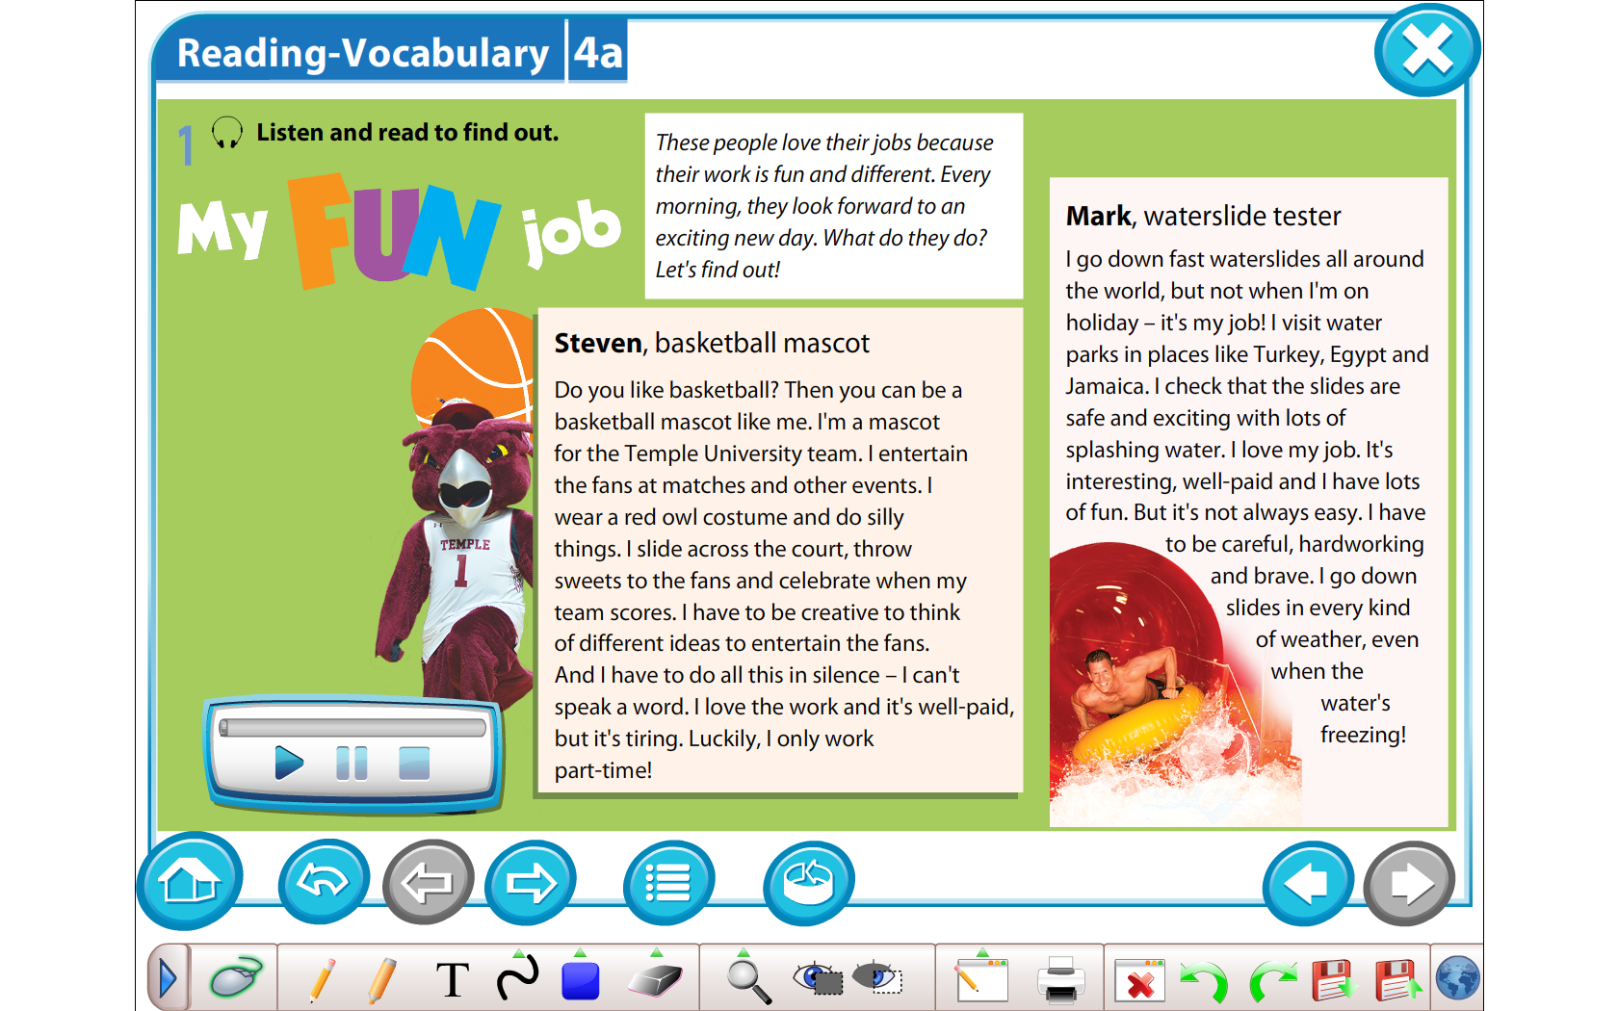  Post listening tasks:  Ex 6 p.47  You must make notes under the six headings. |  |  |  |  |  | DVD-ROM  Worksheet  VIDEO  DVD-ROM  Worksheet
  Name | Steven
  Job | Basketball mascot
  Where works | Temple University
  Job description | Entertain fans, wear a costume, do silly things, celebrate when team scores.
  Qualities for the job | Creative, fit
  Pros and cons | Well –paid but tiring
  Name | Mark
  Job | Waterslide tester
  Where works | Water parks
  Job description | Check slides.
  Qualities for the job | Careful, hardworking, brave
  Pros and cons | Interesting, well –paid, but it isn’t easy.
End  5 min | Feedback  Your marks are…  Home work: Ex 7 p.41 SB, You need write a short text about working as a basketball mascot.  Conclusion: Today you are very active .Thank you for attention
  Assessment criteria | Great | Good | Not very good
  I know 10 new words of professions
  I can ask and answer about jobs
  I can describe professions
Additional information
Differentiation – how do you plan to give more support? How do you plan to challenge the more able learners?  Support for weaker students: working in pairs/groups, phrases  Challenges for moreable students: Encouraged to do more writing; assist weaker students. |  |  | Assessment – how are you planning to check learners’ learning?  Checking the task  Feedback on the work |  | Health and safety check  ICT links  PPT, Video
Differentiation can be by task, by outcome, by individual support, by selection of teaching materials and resources taking into account individual abilities of learners (Theory of Multiple Intelligences by Gardner).  Differentiation can be used at any stage of the lesson keeping time management in mind  Pair work, group work |  |  | Use this section to record the methods you will use to assess what students have learned during the lesson |  | Health promoting techniques  Breaks and physical activities used.  Points from Safety rules used at this lesson.
Reflection  Were the lesson objectives/learning objectives realistic? Did all learners achieve the LO?  If not, why?  Did my planned differentiation work well?  Did I stick to timings?  What changes did I make from my plan and why? |  | Use the space below to reflect on your lesson. Answer the most relevant questions from the box on the left about your lesson.
Summary evaluation

What two things went really well (consider both teaching and learning)?
1:

2:
What two things would have improved the lesson (consider both teaching and learning)?
1:

2:
What have I learned from this lesson about the class or achievements/difficulties of individuals that will inform my next lesson?

Ш. Уәлиханов атындағы №1 жалпы орта білім беретін мектебі

«JOBS»
(ашық сабақ)

Пән мұғалімі: Ахметова Г.Б.

2019-2020 оқу жылы

