Lesson: UNIT 7. Home and garden2 |  | School: №55 secondary school
Date: |  | Teacher name: Tursinova G
Grade: 5 |  | Number present: | Absent:
Lesson title: The house of my dream
Learning objectives (s) that this lesson is contributing to |  | 5.L1 Understand a sequence of supported classroom instructions.  5.W3 Write with support factual descriptions at text level which describe people, places and objects  5.R1understand the main points in a limited range of short simple texts on general and curricular topics  5.S6 Communicate meaning clearly at sentence level during, pair, group and whole class exchanges
Lesson objectives |  | All learners will be able to:
-understand the text
-answer the questions
Most learners will be able to:
-make up sentences using new words;
Some learners will be able to:
-discuss about their different types of houses
-describe their dream houses
Assessment criteria |  | - understand the main idea of the text  - describe their houses  - talk about different types of houses
Language objectives |  | Learners can:  Talk about house of their dream using specific vocabulary of the topic  Key words: a bedroom, a dining room, bathroom, a living room, seat, wall, taste, floor, light
Value links |  | Respect, patriotism, peace
Cross curricular links |  | Art
ICT skills |  | Projector or Smart board for presenting a PPT
Previous learning |  | Learners learned the vocabulary to the topic ‘Designing garden’, described their gardens, and wrote a brochure.
Plan
Time | Planned activities |  |  |  | Resources
Beginning  5 min | Greetings!  Brainstorming. Game technology  Students divided into groups with puzzles. “Garden”, “House”. Suggest students assembling to the pictures and ask them to identify what thing it is. Look the picture without the displaying. Ask students to guess the topic of the lesson.  Teacher introduces the topic and the objectives of the lesson to students. |  |  |  | PPTslide1  Puzzles pictures
Middle  30 min | Critical thinking technology  Task 1 Teacher demonstrates flash cards with words on the topic “The house of my dream” and asks students to repeat the words. Vocabulary game: “Spider” scheme. Learners in small groups decide 10 things a house needs and write them around the drawing of a house. They say ideas and record on board  A house  Descriptor: A learner  - drills words  - finds the objects of houses  - completes the scheme  FA: through smiles.  Task 2. Jigsaw reading strategy .  Differentiation by task for the text:  - All learners read the text and answer the questions  - More able learners asks questions  - Some learners put the sentences in correct order  (P) Natural approach.  Students listen and watch the text, put the sentences in correct order. Teacher plays the recording twice. Students are divided into pairs. They compare their answers with the partner. Teacher checks answers as open-class activity.  Descriptor:  FA: peer assessment worksheet  (G)Task 3. Think- pair- share strategy  Draw your ideal house. Write a few sentences about it. Compare your house with your partner’s and discuss in groups. What is similar/different? Tell the class My ideal house has got ... . There’s a ... in my bedroom. ...There is a ………. My bedroom is cool!  Descriptor: A learner  -describes the houses  - compares houses with the text  - discuss about their ideal house  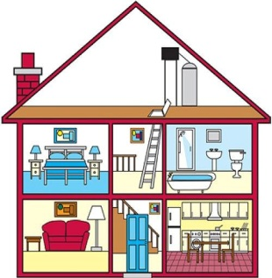  FA: through smiles   |  |  |  | PPTslide1  pictures  Flash cards  cluster  Smiles  PPT slide 2  Paper marker  PPT slide 3  CD  worksheet  PPT slide 4  Cards  pictures  smiles
  A learner | Yes | No
  listens the text
  underlines unfamiliar words
  asks questions
  puts the sentences in correct order
  compares answers with partner
End  5 min | Assessment. Traffic light.  Feedback. The teacher gives comments about learners work and awards learner. Students will choose one and put on the board their stickers.  Home task: Writing and speaking “My dream house” Use what you know  Draw your house and furniture’s in the paper. Make a dialogue with your partner about your room. |  |  |  | 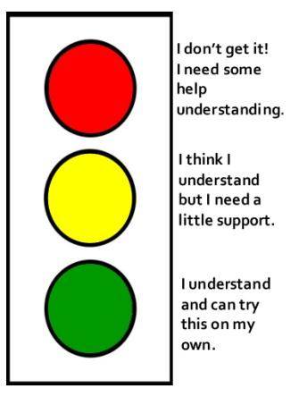  Stickers  PPT slide 5
Additional information
Differentiation – how do you plan to give more support? How do you plan to challenge the more able learners? |  | Assessment – how are you planning to check learners’ learning? |  | Health and safety check  ICT links
- Less able learners will be able to underline new words and explain their meanings  - Most able students will be able to  ask 3-5 questions about the specific details of the text.  make up sentences using new words  -More able students will be able to  understand the text, answers the questions |  | - Pair assessment with smiles in pair work, positive smiles for good describing, negative smiles for unclear answers  - Group assessment with smiles in group work  - Students fill in assessment sheets (put ticks and crosses) |  | Safety health technology  ICT  Art
Reflection  Were the Lesson Objectives/Learning objectives realistic?  What did the learners learn today?  What was the learning atmosphere like?  Did my planned differentiation work well?  Did I stick to timings? What changes did I make from my plan and why? |  | Use the space below to reflect on your lesson. Answer the most relevant questions from the box on the left about your lesson.
Summary evaluation
What two things went really well (consider both teaching and learning)?

1:

2:
What two things would have improved the lesson (consider both teaching and learning)?

1:

2:

What have I learned from this lesson about the class or achievements/ difficulties of individuals that will inform my next lesson?

